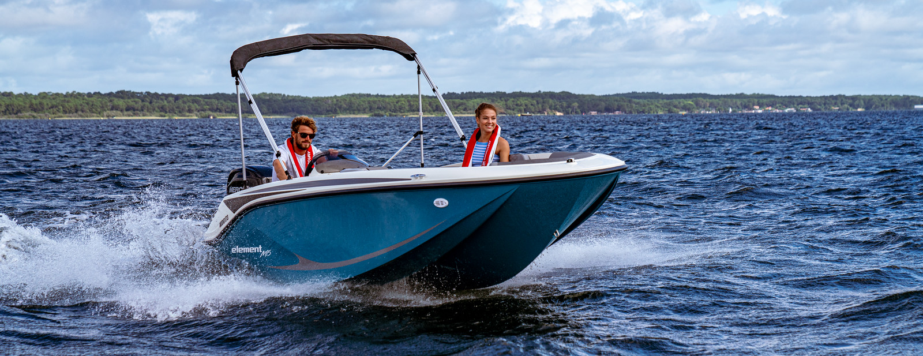

2022
M15
4,62 m x 2,01 m
628 kg (excl. Engine)
Leverbaar vanaf: € 13.150,-
Standaard uitgevoerd met:
Mercury 4st Rigging
White Gelcoat Hull and Deck
Custom Sport Steering Wheel
Dual Purpose Gauge: Speedometer, Voltmeter
Helm Windscreen
12v Accessory Outlet
12v Horn
1200 Gph Bilge Pump
Swim Platform w/ Telescoping Ladder
Battery On/Off Switch
CE Option
CE Approved Fire Suppression System - Automatic

Uitgevoerd met de onderstaande opties:
Canvas Options:
Snap On Cover € 675,-

Options & Accessories:
Bow filler cushion € 415,-
Stereo with speakers € 660,-

Delivery Package: Fire extinguisher, registration number, 4 fenders, 4 fender lines, 4 mooring lines, 50 liters of fuel.

Totaal vaarklaar: € 14.900,-
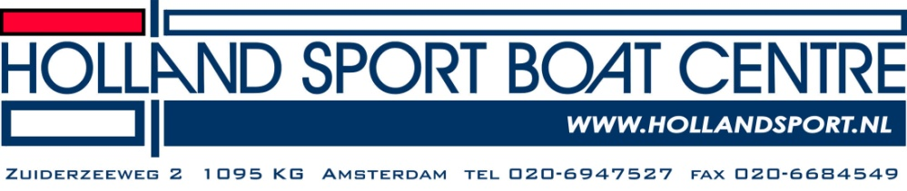

All prices are in Euro, including 21% VAT and including delivery costs. The available options on this pricelist can differ from the options in the brochure. We cannot be held responsible for any editing errors that may occur. Prices are subject to change without announcement. Upon issue of this pricelist, all former pricelists are no longer valid. Prices for options are based on factory installation, any options ordered after delivery will incur additional charges.
15EL#139

