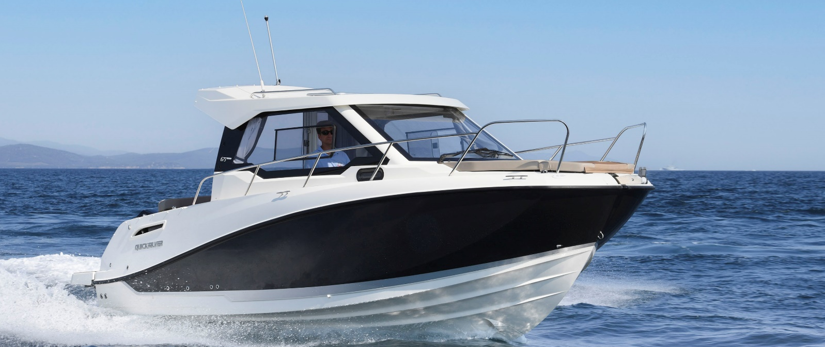
Quicksilver Activ 675
Weekend

Specifications: € 56.360,-
Length: 6.94 m
Width: 2.50 m
Estimated draft: 0.48 m
Dry Weight: 1.848 kg
Fuel tank volume: 200 L

This boat is standard equipped with the following options:

Mercury F150
Bow Roller
Swim Ladder
Navigation Lights
Forward Line/Anchor Locker
Self Bailing Cockpit
Rod holders
Swim Platforms
LED Courtesy lights
SmartCraft Speedometer/Tachometer
12v Electrical Socket
Aft Bench Seat
Storage below A Seat
Cockpit Cushions
Upgraded Cockpit Table
Cockpit Shower
Transom Door
Aft Seat Extension L-Lounge
3 Berths
Storage below Berth
Pilot Seats with Flip Bolster and Swivel
Dinette Seat Configuration
Berth Cushion/Filler
Deck Hatch
Sink with Tap
Dual Battery System
CO Monitor
Smoke Detector
Fire Extinguisher
Hydraulic Steering
Electric & Manual Bilge Pump
Starboard Windscreen Wiper
Windscreen Wash
OB Pre-Rigging
VesselView Mobile
Active Trim 175 HP and up

Delivery Package: Fire extinguisher, registration number, 4 fenders, 4 fender lines, 4 mooring lines, 50 liters of fuel.

Engine Options:
Mercury 175 V6 € 4.490,-
Mercury 200 V6 € 5.020,-
Mercury 225 V6 € 6.530,-

Options & Accessories:
Freight € 2.880,-
Swim Platform Extensions € 840,-
Flexiteek Flooring € 1.970,-
Extended Swim Platform With Flexiteek € 1.090,-
Hull Color (Dark Grey) € 1.170,-
Forward Sun Lounge € 660,-
Cockpit Sun Lounge € 850,-
Real teak cockpit table € 1.060,-
Curtains € 1.170,-
Roof Hatch € 1.590,-
Hatch Screen Cover (Hatch Cover and Mosquito Net) € 600,-
Enclosed sea toilet with sink, port & starboard portlights € 2.040,-
Stove LPG € 650,-
Shore Power € 1.870,-
DAB Stereo Kit with Antenna (Electronics Pack) € 270,-
Simrad VHF RS20 (Electronics Pack) € 610,-
Grey Water System with Dock Discharge € 590,-
Grey Water System with Manual Discharge € 960,-
Mooring Kit € 330,-
Bow Thruster € 3.300,-
Diesel Heating € 5.040,-
Bow Electrical Windlass € 2.400,-
Zipwake Dynamic Trim-Control € 2.470,-
Active Trim up to 150 HP € 820,-
Bimini € 1.550,-
SMART Edition* € 7.480,-
Electronics Pack** € 3.230,-
Electronics Pack with Larger GPS Screen*** € 5.320,-

Canvas options:
Sun Awning € 1.230,-
Bimini with Enclosed Canvas € 2.760,-

* Cockpit Sun Lounge, Cockpit Lighting, Real Teak Cockpit Table, Curtains, Roof Hatch, Refrigerator, Mooring Kit, Bow Electrical Windlass

** Stereo Fusion With 4 Speakers, Simrad Gps/Chart Plotter 7" Nss Evo3s With Hdi Transducer, Vesselview Link Digital Interface

*** Stereo Fusion With 4 Speakers, Simrad Gps/Chart Plotter 9" Nss Evo3s With Hdi Transducer, Vesselview Link Digital Interface

