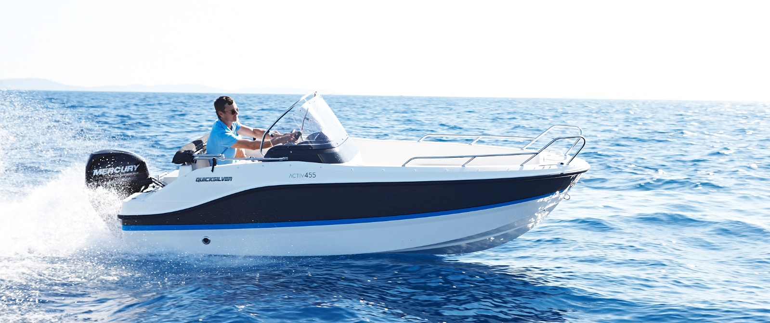
Quicksilver Activ 455 Open

Specifications: € 19.730,-
Length: 4.54 m
Width: 1.85 m
Estimated draft: 0.25 m
Dry Weight: 501 kg
Fuel tank volume: 25 L

This boat is standard equipped with the following options:

Mercury F40 PK – 3 Cyl
OB Pre-Rigging
Swim Ladder
Navigation Lights
Forward Line/Anchor Locker
Self Bailing Cockpit
Analog Speedometer/Tachometer
Trim Gauge
12v Electrical Socket
Cockpit Cushions
Aft Bench Seat
Storage below Aft Seat
Single Battery System
Electric & Manual Bilge Pump
Fire Extinguisher
Mechanical Steering

Delivery Package: Fire extinguisher, registration number, 4 fenders, 4 fender lines, 4 mooring lines, 50 liters of fuel.

Engine Options:
Mercury F40 € 210,-
Mercury F50 € 530,-
Mercury F60 € 1.480,-
Mercury F60 CT € 2.140,-

Options & Accessories:
Freight € 1.270,-
Hull Color (Dark Grey) € 640,-
Bow Kit (convertible bow sun lounge, bow cushions) € 720,-
Stereo Fusion with 2 Speakers € 860,-
Simrad GPS/Chart Plotter Cruise 7 with HDI Transducer € 1.330,-
DAB Stereo Kit with Antenna € 280,-
Bimini € 1.450,-
Mooring Kit € 350,-

Canvas options:
Mooring Cover € 720,-

