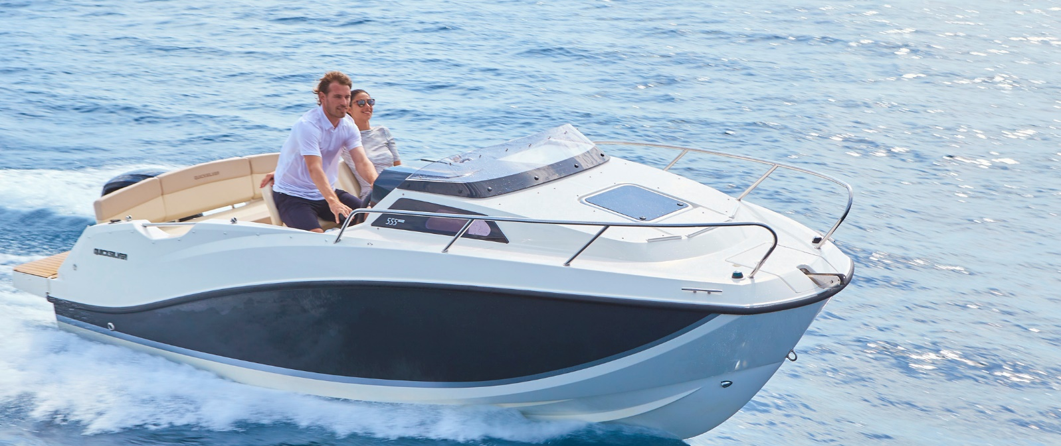
Quicksilver Activ 555
Cabin

Specifications: € 31.720,-
Length: 5.50 m
Width: 2.29 m
Estimated draft: 0.42 m
Dry Weight: 1.028 kg
Fuel tank volume: 110 L

This boat is standard equipped with the following options:

Mercury F80 PK
Bow Roller
Swim Ladder
Navigation Lights
Forward Line/Anchor Locker
Self Bailing Cockpit
Rod Holders
Swim Platforms
Analog Speedometer/Tachometer
Trim Gauge
Fuel Gauge
12v Electrical Socket
Pilot Seat with Flip Bolster and Swivel

Cockpit Cushions
Cockpit Table
Aft Bench Seat
Storage below Aft Seat
2 berths
Deck Hatch
OB Pre-Rigging
Single Battery System
Electric & Manual Bilge Pump
Hydraulic Steering
CO Monitor
Fire Extinguisher
VesselView Mobile

Delivery Package: Fire extinguisher, registration number, 4 fenders, 4 fender lines, 4 mooring lines, 50 liters of fuel.

Engine Options:
Mercury F100 € 1.810,-
Mercury F100 CT € 2.800,-
Mercury F115 € 2.760,-
Mercury F115 CT € 3.790,-

Options & Accessories:
Freight € 1.770,-
Flexiteek Flooring € 2.450,-
Swim Platform Extensions € 700,-
Swim Platform Extensions with Flexiteek € 930,-
Hull Color (Dark Grey) € 760,-
Forward Sun Lounge € 650-
SmartCraft Speedometer/Tachometer € 860,-
Active Trim € 860,-
Stereo Fusion with 4 speakers € 840,-
DAB Stereo Kit with Antenna € 280,-
Simrad GPS/Chart Plotter Cruise 7'' NISS evo3s with HDI Transducer € 1.330,-
Co-pilot Seat € 620,-
Cockpit Sun Lounge € 770,-
Back Bench Filler with Cushion € 750,-
Refrigerator € 1.390,-
Cabin Table and Berth Cushion/Filler € 570,-
Mooring Kit € 350,-
SMART Edition* € 3.890,-

Canvas options:
Bimini with Enclosed Canvas € 2.390,-
Mooring Cover € 890,-

* Bimini With Enclosed Canvas, Co-Pilot Seat, Back Bench Filler With Cushion, Cabin Table & Berth Cushions/Filler

