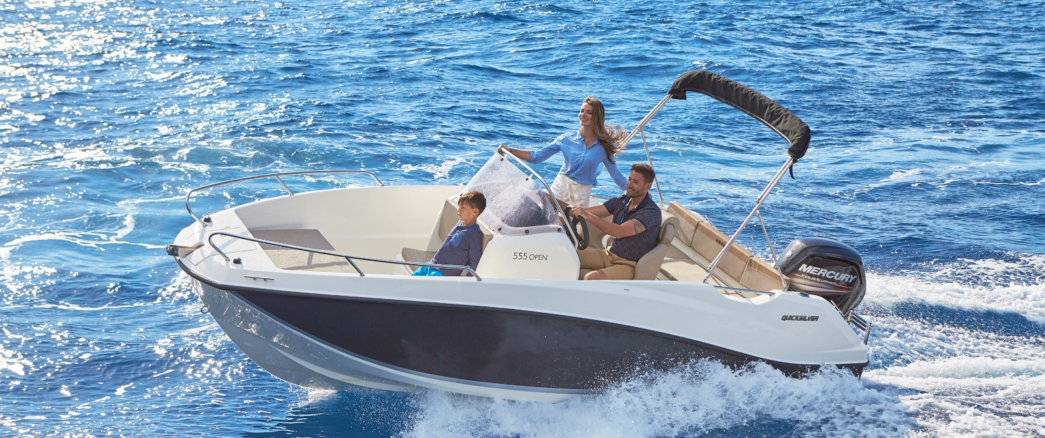
Quicksilver Activ 555 Open

Specifications: € 29.180,-
Length: 5.47 m
Width: 2.29 m
Estimated draft: 0.36 m
Dry Weight: 885 kg
Fuel tank volume: 110 L

This boat is standard equipped with the following options:

Mercury F80 PK
OB Pre-Rigging
Bow Roller
Swim Ladder
Navigation Lights
Forward Line/Anchor Locker
Self Bailing Cockpit
Rod Holders
Swim Platforms
Analog Speedometer/Tachometer
Fuel Gauge
Trim Gauge
12v Electrical Socket
Aft Bench Seat
Pilot Seat with Flip Bolster and Swivel
Co-pilot Seat
Cockpit Cushions
Storage below Aft Seat
Single Battery System
Electric & Manual Bilge Pump
Hydraulic Steering
Fire Extinguisher
VesselView Mobile

Delivery Package: Fire extinguisher, registration number, 4 fenders, 4 fender lines, 4 mooring lines, 50 liters of fuel.

Engine Options:
Mercury F100 € 1.810,-
Mercury F100 CT € 2.800,-
Mercury F115 € 2.760,-
Mercury F115 CT € 3.790,-

Options & Accessories:
Freight € 1.820,-
Ski Pole € 720,-
Hull Color (Dark Grey) € 780,-
Swim Platform Extensions € 700,-
Bow Sun Lounge Side Extension € 500,-
Bow Kit* € 960,-
Stereo Fusion with 2 speakers € 860,-
Simrad GPS/Chart Plotter Cruise 7 with HDI Transducer € 1.330,-
SmartCraft Speedometer/Tachometer € 860,-
DAB Stereo Kit with Antenna € 280,-
Active Trim € 860,-
Leaning Post € 240,-
Motor Bracket € 340,-
Mooring Kit € 350,-
Bimini € 1.450,-
SMART Edition** € 3.570,-

Canvas options:
Transport Cover € 1.450,-
Console & Bolster Seats Cover € 480,-
Console & Leaning Post Cover € 630,-

* Convertible Bow Sun Lounge, Bow Cushions, Bow Table

** Bimini, Ski Pole, Stereo Fusion With 2 Speakers, Bow Kit (Convertible Bow Sun Lounge, Bow Cushions, Bow Table)

