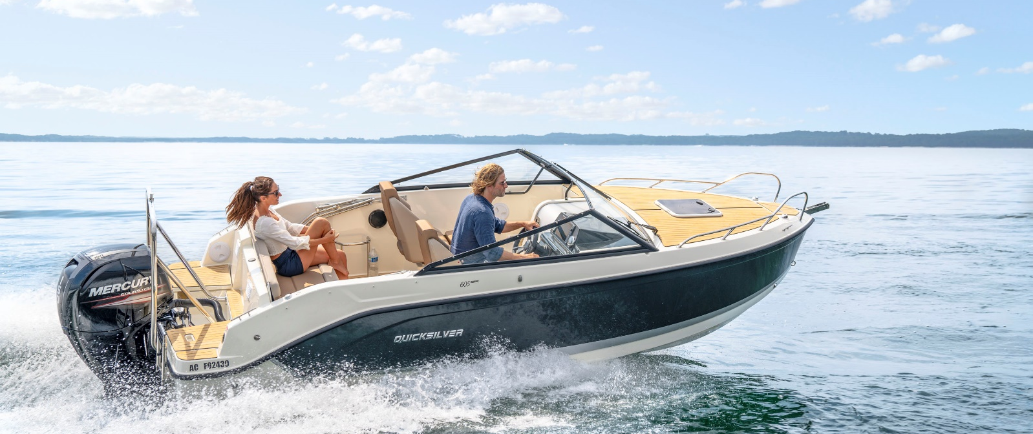
Quicksilver Activ 605
Cruiser

Specifications: € 43.610,-
Length: 6.00 m
Width: 2.34 m
Estimated draft: 0.48 m
Dry Weight: 1.237 kg
Fuel tank volume: 160 L

This boat is standard equipped with the following options:

Mercury F115 PK
Bow Roller
Swim Ladder
Navigation Lights
Forward Line/Anchor Locker
Swim Platforms
Self Bailing Cockpit
SmartCraft Speedometer/Tachometer
Pilot Seat with Flip Bolster and Swivel
Co-pilot Seat
Cockpit Table with Laminated Top
Aft Bench Seat
Storage below Aft Seat
Cockpit Cushions
2 berths
Storage below Berth
Berth Cushion/Filler
Deck Hatch
Cabin Lights
Single Battery System
Fire Extinguisher
Hydraulic Steering
Electric & Manual Bilge Pump
OB Pre-Rigging
VesselView Mobile

Delivery Package: Fire extinguisher, registration number, 4 fenders, 4 fender lines, 4 mooring lines, 50 liters of fuel.

Engine Options:
Mercury F115 CT € 1.030,-
Mercury F150 € 3.440,-

Options & Accessories:
Freight € 2.140,-
Ski Tow Bar € 890,-
Flexiteek Flooring € 3.590,-
Hull Color (Dark Grey) € 1.030,-
Forward Sun Lounge € 810,-
Active Trim € 860,-
Stereo Fusion with 2 speakers € 860,-
DAB Stereo Kit with Antenna € 280,-
Cockpit Sun Lounge € 790,-
Real Teak Cockpit Table € 830,-
Cockpit Shower € 750,-
Refrigerator € 1.390,-
Mooring Kit € 350,-
Bimini € 1.560,-
SMART Edition* € 3.530,-
Electronics Pack** € 2.160,-

Canvas options:
Bimini with Enclosed Canvas € 2.720,-
Mooring Cover € 920,-

* Cockpit Shower, Refrigerator, Mooring Kit, Real Teak Cockpit Table, Bain De Soleil Arrière

** Stereo Fusion With 2 Speakers, Simrad Gps/Chart Plotter Cruise 7 With Hdi Transducer

