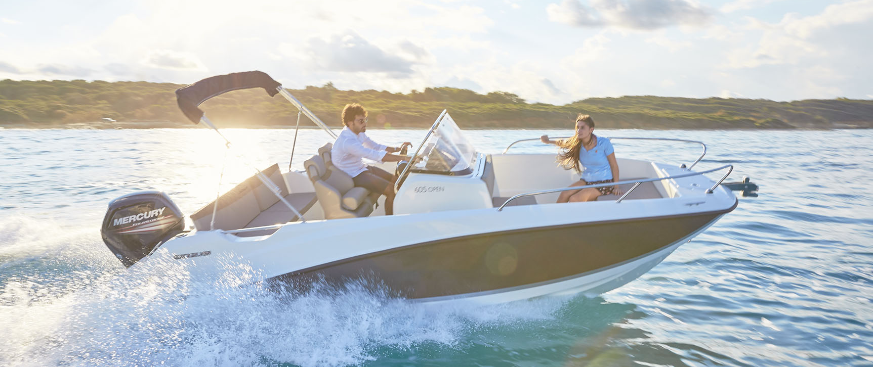
Quicksilver Activ 605 Open

Specifications: € 35.450,-
Length: 5.95 m
Width: 2.40 m
Estimated draft: 0.38 m
Dry Weight: 1.067 kg
Fuel tank volume: 160 L

This boat is standard equipped with the following options:

Mercury F115 PK
OB Pre-Rigging
Bow Roller
Swim Ladder
Navigation Lights
Forward Line/Anchor Locker
Self Bailing Cockpit
Rod Holders
Swim Platforms
12v Electrical Socket
SmartCraft Speedometer/Tachometer
Aft Bench Seat
Pilot Seat with Flip Bolster and Swivel
Co-pilot Seat
Cockpit Cushions
Storage below Aft Seat
Single Battery System
Electric & Manual Bilge Pump
Hydraulic Steering
Fire Extinguisher
VesselView Mobile

Delivery Package: Fire extinguisher, registration number, 4 fenders, 4 fender lines, 4 mooring lines, 50 liters of fuel.

Engine Options:
Mercury F115 CT € 1.030,-
Mercury F150 € 3.370.-

Options & Accessories:
Freight € 2.140,-
Flexiteek Flooring € 3.280,-
Hull Color (Dark Grey) € 1.030,-
Ski Pole € 720,-
Swim Platform Extensions with Flexiteek € 870,-
Swim Platform Extensions € 700,-
Bow Sun Lounge Side Extension € 550,-
Bow Kit* € 980,-
Stereo Fusion with 2 speakers € 860,-
Simrad GPS/Chart Plotter Cruise 7 with HDI Transducer € 1.330,-
DAB Stereo Kit with Antenna € 280,-
Active Trim € 860,-
Leaning Post with 12v Cool Box € 300,-
Cockpit Shower € 750,-
Motor Bracket € 340,-
Bow Electrical Windlass € 2.520,-
Mooring Kit € 350,-
Bimini € 1.450,-
SMART Edition** € 4.540,-

Canvas options:
Transport Cover € 1.550,-
Console & Bolster Seats Cover € 500,-
Console & Leaning Post Cover € 660,-

* Convertible Bow Sun Lounge, Bow Cushions, Bow Table

** Bimini, Ski Pole, Stereo Fusion With 2 Speakers, Cockpit Shower, Bow Kit (Convertible Bow Sun Lounge, Bow Cushions, Bow Table), Mooring Kit

