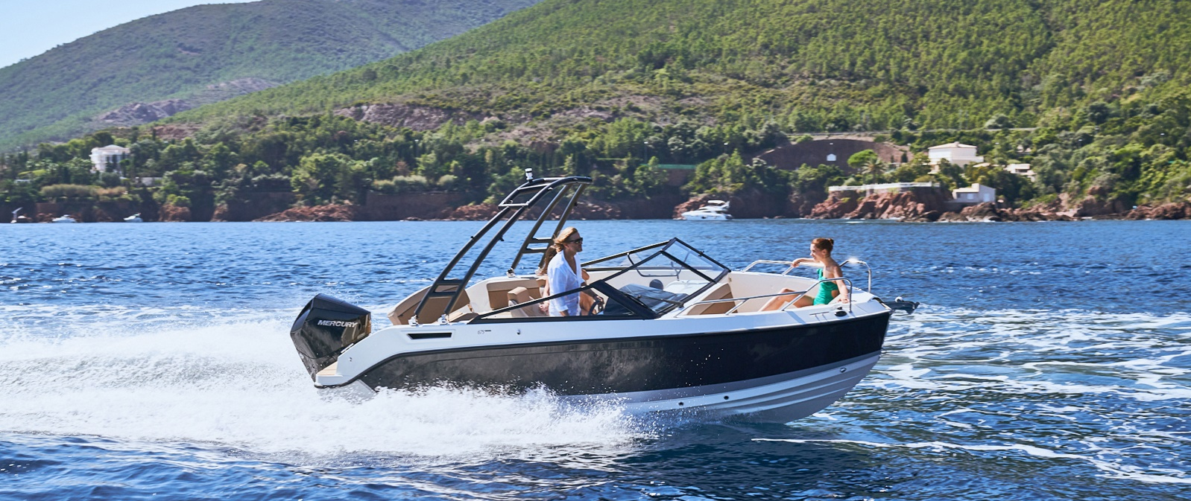
Quicksilver Activ 675
Bowrider

Specifications: € 51.230,-
Length: 6.40 m
Width: 2.46 m
Estimated draft: 0.46 m
Dry Weight: 1.480 kg
Fuel tank volume: 230 L

This boat is standard equipped with the following options:

Mercury F150 PK
Bow Roller
Swim Ladder
Navigation Lights
Forward Line/Anchor Locker
Self Bailing Cockpit
Swim Platforms
Motorwell Bridge
SmartCraft Speedometer/Tachometer
Active Trim 175 HP and up
Pilot Seat with Flip Bolster and Swivel
Co-pilot Seat
Cockpit Table
Cockpit Cushions
Aft Bench Seat
Aft Seat Folding Backrest
Storage below Aft Seat
OB Pre-Rigging
Single Battery System
Electric & Manual Bilge Pump
Hydraulic Steering
Starboard Windscreen Wiper
Fire Extinguisher
CO Monitor
VesselView Mobile
Cabin Lights
Opening Portlights
Bow Cushions

Delivery Package: Fire extinguisher, registration number, 4 fenders, 4 fender lines, 4 mooring lines, 50 liters of fuel.

Engine Options:
Mercury 175 V6 € 5.000,-
Mercury 200 V6 € 5.540,-
Mercury 225 V6 € 7.000,-

Options & Accessories:
Freight € 2.970,-
Ski Pole € 880,-
Flexiteek Flooring € 3.120,-
Hull Color (Dark Grey) € 1.120,-
Swim Platform Extensions € 700,-
Extended Swim platforms with Flexiteek € 870,-
Forward Sun Lounge € 270,-
Active Trim up to 150 HP € 860,-
DAB Stereo Kit with Antenna € 280,-
Stereo Fusion with 2 Speakers € 860,-
Real Teak Cockpit Table and Cockpit Sun Lounge € 1.270,-
Cockpit Shower € 750,-
Starboard Flip Seat € 1.330,-
Galley (sink with tap, stove butane, cockpit shower) € 1.370,-
Galley (with SMART Edition) (sink with tap, stove butane) € 820,-
Sea Toilet € 2.110,-
Sink with Tap € 340,-
Refrigerator € 1.390,-
Mooring Kit € 350,-
Bow Electrical Windlass € 2.520,-
ZipWake Dynamic Trim-Control € 2.590,-
Bimini € 1.540,-
Wakeboard Tower with Bimini € 3.760,-
SMART Edition* € 5.750,-
Electronics Pack** € 2.680,-

Canvas options:
Bimini with Enclosed Canvas € 2.570,-
Mooring Cover € 1.140,-

* Led Courtesy Lights, Refrigerator, Cockpit Shower, Stereo Fusion With 2 Speakers, Simrad Gps/Chart Plotter Cruise 9 With Hdi Transducer, Real Teak Cockpit Table , Cockpit Sun Lounge

** Stereo Fusion With 2 Speakers, Simrad Gps/Chart Plotter Cruise 9 With Hdi Transducer

