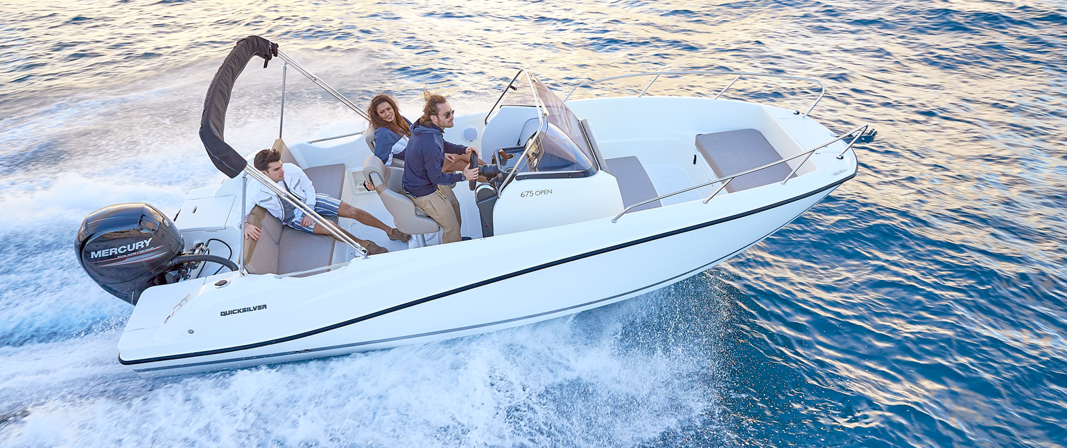
Quicksilver Activ 675 Open

Specifications: € 45.250,-
Length: 6.66 m
Width: 2.55 m
Estimated draft: 0.41 m
Dry Weight: 1.290 kg
Fuel tank volume: 200 L

This boat is standard equipped with the following options:

Mercury F150 PK
Bow Roller
Swim Ladder
Navigation Lights
Forward Line/Anchor Locker
Self Bailing Cockpit
Rod Holders
Swim Platforms
12v Electrical Socket
SmartCraft Speedometer/Tachometer
Aft Bench Seat
Pilot Seat with Flip Bolster and Swivel
Co-pilot Seat
Cockpit Cushions
Cockpit Table
Storage below Aft Seat
1 Berth
Berth Cushions/Filler
OB Pre-Rigging
Single Battery System
Electric & Manual Bilge Pump
Hydraulic Steering
CO Monitor
Fire Extinguisher
VesselView Mobile

Delivery Package: Fire extinguisher, registration number, 4 fenders, 4 fender lines, 4 mooring lines, 50 liters of fuel.

Engine Options:
Mercury F175 V6 € 5.000,-
Mercury F200 V6 € 5.540.-
Mercury F225 V6 € 7.100,-

Options & Accessories:
Freight € 2.970,-
Flexiteek Flooring € 3.930,-
Hull Color (Dark Grey) € 1.100,-
Ski Pole € 720,-
Swim Platform Extensions € 700,-
Swim Platform Extensions with Flexiteek € 870,-
Bow Sun Lounge Side Extension € 600,-
Bow Kit* € 910,-
Bow table € 290,-
Stereo Fusion with 2 speakers € 860,-
Simrad GPS/Chart Plotter Cruise 7 with HDI Transducer € 1.330,-
DAB Stereo Kit with Antenna € 280,-
Active Trim up to 150 HP € 860,-
Cockpit Shower € 750,-
Upgraded Cockpit Table € 340,-
Leaning Post with 12v Cool Box € 330,-
Motor Bracket € 340,-
Bow Electrical Windlass € 2.520,-
Mooring kit € 350,-
Bimini € 1.450,-
SMART Edition** € 5.740,-

Canvas options:
Transport Cover € 2.260,-
Console & Bolster Seats Cover € 550,-
Console & Leaning Post Cover € 730,-

* Convertible Bow Sun Lounge, Bow Cushions, Bow Table

** Bow Kit (Convertible Bow Sun Lounge, Bow Cushions), Ski Pole, Stereo Fusion With 2 Speakers, Cockpit Shower, Bow Electrical Windlass, Upgraded Cockpit Table, Mooring Kit

