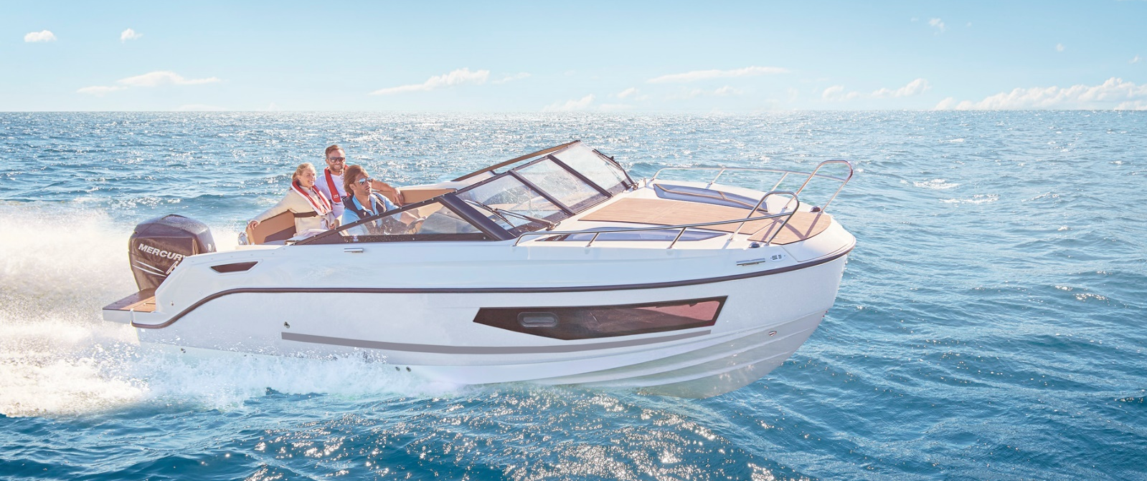
Quicksilver Activ 755
Cruiser

Specifications: € 65.180,-
Length: 7.37 m
Width: 2.55 m
Estimated draft: 0.55 m
Dry Weight: 1.655 kg
Fuel tank volume: 280 L

This boat is standard equipped with the following options:

Mercury F175 PK V6
Bow Roller
Swim Ladder
Navigation Lights
Forward Line/Anchor Locker
Self Bailing Cockpit
Swim Platforms
Hull Side Windows
SmartCraft Speedometer/Tachometer
12v Electrical Socket
Adjustable Steering Position
Active Trim
Pilot Seat with Flip Bolster and Swivel
Co-pilot Seat
Upgraded Cockpit Table
Cockpit Cushions
Aft Bench Seat
Aft Seat Extension L-Lounge
Aft Seat Folding Backrest
12v Cool Box (not provided with Smart/Cockpit Comfort Pack)
Storage below Aft Seat
2 berths
Berth Cushions/Filler
Cabin Lights
Opening Portlights
Storage below Berth
Opening Portlights
OB Pre-Rigging
Dual Battery System
Electric & Manual Bilge Pump
Hydraulic Steering
Starboard Windscreen Wiper
Fire Extinguisher
CO Monitor
VesselView Mobile

Delivery Package: Fire extinguisher, registration number, 4 fenders, 4 fender lines, 4 mooring lines, 50 liters of fuel.

Engine Options:
Mercury 200 V6 € 540,-
Mercury 225 V6 € 2.090,-
Mercury 250 V8 Verado € 7.030,-
Mercury 300 V8 Verado € 12.920,-

Options & Accessories:
Freight € 3.170,-
Flexiteek Flooring € 4.750,-
Swim Platform Extensions with Flexiteek € 1.140,-
Swim Platform Extensions € 880,-
Hull Color (Dark Grey) € 1.210,-
Ski Pole € 880,-
Forward Sun Lounge € 1.070,-
Real Teak Cockpit Table € 1.200,-
Cockpit Sun Lounge € 550,-
DAB Stereo Kit with Antenna (SMART Edition) € 280,-
Bow Electrical Windlass € 2.620,-
Electric Trim Tabs € 1.820,-
Grey Water System with Dock Discharge (80L) € 620,-
Diesel Heating € 4.280,-
Mooring Kit € 590,-
Bow Thruster € 3.460,-
Bimini € 1.960,-
SMART Edition* € 14.030,-
Cockpit Comfort Pack** € 7.130,-
Cabin Comfort Pack*** € 2.620,-
Electronic Pack**** € 5.590,-

Canvas options:
Bimini with Enclosed Canvas € 2.910,-
Mooring Cover € 1.430,-

* Cockpit Shower, Ski Pole, Refrigerator, Stove Lpg, Port Windscreen Wiper & Windshield Wash, Sink With Tap, Cockpit Sun Lounge, Real Teak Cockpit Table, Led Courtesy Lights, Enclosed Sea Toilet, Curtains, Simrad Gps/Chart Plotter 9" Nss Evo3s With Hdi Transducer, Stereo Fusion With 4 Speakers, Vesselview Link Digital Interface, Mooring Kit

** Cockpit Sun Lounge, Refrigerator, Stove Lpg, Port Windscreen Wiper & Windshield Wash, Cockpit Shower, Ski Pole, Sink With Tap, Real Teak Cockpit Table, Led Courtesy Lights

*** Enclosed Sea Toilet, Curtains

**** Simrad Gps/Chart Plotter 9" Nss Evo3s With Hdi Transducer, Stereo Fusion With 4 Speakers, Vesselview Link Digital Interface

