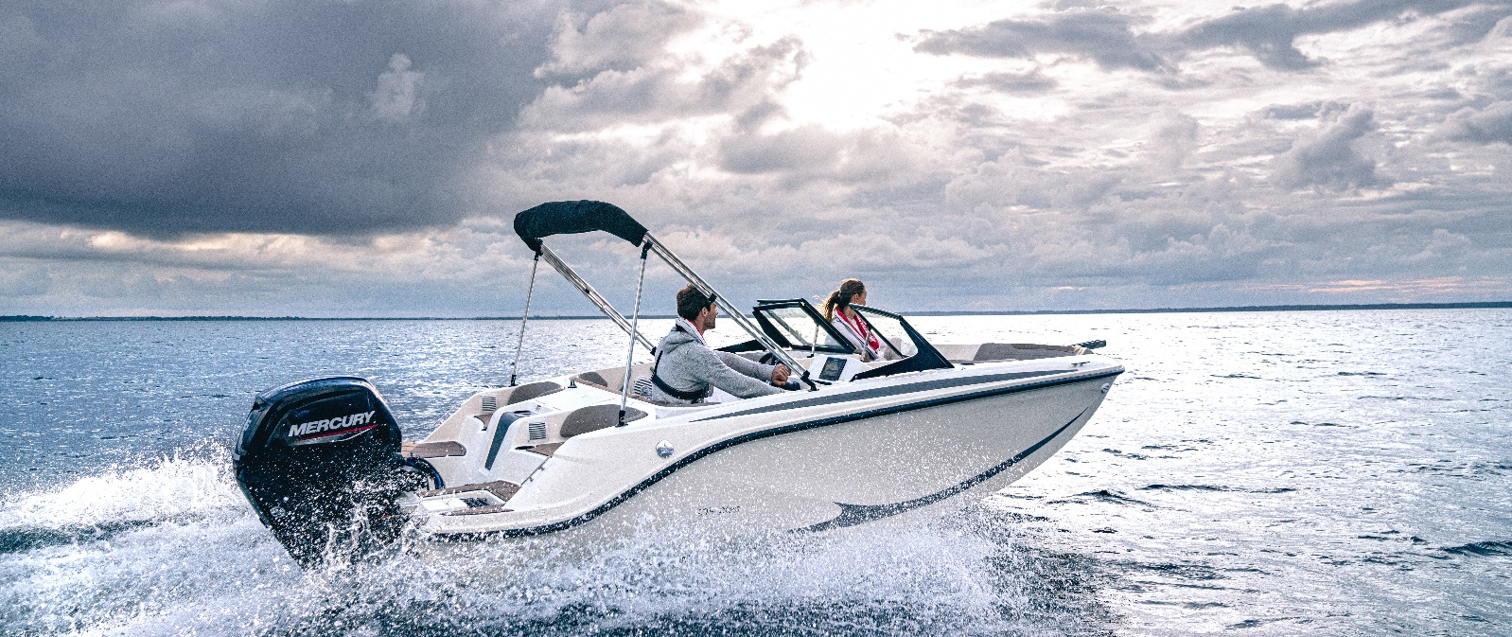
Quicksilver 525 aXess

Specifications: €27.960 ,-
Length: 5.35 m
Width: 2.29 m
Estimated draft: 0.25 m
Dry Weight: 750 kg
Fuel tank volume: 68 L

This boat is standard equipped with the following options:

Mercury F 60 PK
OB Pre-Rigging
Bow Roller
Swim Ladder
Navigation Lights
Forward Line/Anchor Locker
Swim Platforms
GatorStep Flooring (Almond)
Convertible bow sun lounge
Bow Cushions
Bow table
Analog Speedometer/Tachometer
Trim Gauge
12v Electrical Socket
Helm Bench Seat
Aft Bench Seat
Storage below Aft Seat
Cockpit Cushions
Portside Lounge Seat
Stereo Jensen with 2 speaker
VesselView Mobile
Digital Depth Indicator
12v Horn
Mooring Kit
Single Battery System
Fire Extinguisher
Mechanical Steering
Electric & Manual Bilge Pump
Full windshield with opening central panel
Bimini

Delivery Package: Fire extinguisher, registration number, 4 fenders, 4 fender lines, 4 mooring lines, 50 liters of fuel.

Engine Options:
Mercury F60 CT € 830,-
Mercury F80 € 3.030,-
Mercury F100 € 4.840,-
Mercury F100 CT € 5.830,-
Mercury F115 € 5.790,-
Mercury F115 CT € 6.820,-

Options & Accessories:
Freight € 1.230,-
Ski Pole € 800,-
Simrad GPS/Chart Plotter GO7 with HDI Transducer € 2.220,-
Hydraulic Steering € 860,-

Canvas options:
Mooring Cover € 1.120,-

